NOTE ON AGCHEM CALIBRATION

For land uses calibrated with AGCHEM module, different codes and scripts are used for different land uses, for both nitrogen and phosphorus, depending on the plant uptake methods and availability of field uptake data.

- Script and codes
1.1 Land uses using yield-based uptake method
Four land uses – hwm, hom, lwm, and alf, are simulated with yield-based uptake method, so they are calibrated essentially the same way.

The script for running nutrient calibration for hwm, hom, lwm, and alf is: run_crop_optim.csh LandScenario, caibrationlscenario, basin.

The Codes for land uses using yield-based uptake method:
./code/calibration_utils/change_param/calib_iter/NITR_crop/. (nitrogen)
./code/calibration_utils/change_param/calib_iter/PHOS_crop/. (phosphorus)

Although alf uses the yield-based uptake method, it doesn’t need to adjust wilting point to reach uptake targets because of the legume fixation feature of this land use. As a result, the nitrogen codes are slightly different then what for the above land uses, but phosphorus is calibrated the same way. In the script, a ‘if’ statement is used to specify a different nitrogen .exe file for alf.

The Codes for alf calibration is at:
./code/calibration_utils/change_param/calib_iter/NITR_alf/. (nitrogen)

1.2 hyw using first-order uptake method
Ideally, nitrogen for hyw should be calibrated the same way as crop, using the yield-based uptake method. However, for p53 and p532, a first-order method was used because the application data from Scenario Builder were (wrongly) concentrated in one or two months, which makes uptake much lower than target and in turn export from surface extremely high. Switching to a first-order approach is basically an attempt to compensate some of input data problems. In the future, if the data problem is fixed, it is suggested that hyw should be calibrated the same way as crop. Phosphorus is calibrated the same way as crop.

The script for running hyw calibration is:
run_hyw_optim.csh LandScenario, caibrationlscenario, basin.

This separated script is used because of somewhat ambivalent nature of hyw calibration approach. In the future, if it becomes certain which uptake method will be used, the script: run_crop_optim.csh can be used, either directly (for yield-based method) or by adding a ‘if’ statement for hyw, just like for alf (for first-order method)

The codes for hyw using first-order uptake method:
./code/calibration_utils/change_param/calib_iter/NITR_hyw/. (nitrogen)
Phosphorus uses the same code as crop.

  - pasture using first-order uptake method
Pasture land use is simulated with first-order uptake method but also has ammonia volatilization rate adjusted to meet the targets, so this land use is calibrated in its own way for nitrogen. Phosphorus is calibrated the same way as crop.

The script to run pasture calibration is also:
run_crop_optim.csh LandScenario, caibrationlscenario, basin.
with a ‘if’ statement to specify a different nitrogen .exe file for pas.

The codes for pas using first-order uptake method:
./code/calibration_utils/change_param/calib_iter/NITR_pasture/. (nitrogen)
Phosphorus uses the same code as crop.

  - land uses using first-order uptake method but no uptake data
Four land uses – hyo, rpd, npd, cpd, are simulated with first-order uptake method but without uptake data available, so they are calibrated the same way for nitrogen. Phosphorus calibration for these four land uses is handled by PQUAL so is not included in the script

The script of running nitrogen calibration is:
run_noncrop_optim.csh LandScenario, caibrationlscenario, basin.

The codes for noncrop land uses using first-order uptake method:
./code/calibration_utils/change_param/calib_iter/NITR_noncrop/. (nitrogen)

The codes were also developed for phosphorus for these land uses and they are at:
./code/calibration_utils/change_param/calib_iter/PHOS_noncrop/.
But in the course of calibration, it is found that the approach performs poorly because there is no phosphate application to these land uses and a mass-balance approach may not be appropriate. As a result, phosphorus calibration was switched to PQUAL, and the codes now serve only as a historical record or alternative approach.

  - Forest land use
Nitrogen calibration for the forest, woodlots, and wooded land use is handled in its own way to maintain a stable storage over time. Phosphorus calibration of forest is handled by PQUAL so is not included in the script

The script to run forest calibration is:
run_for_optim.csh LandScenario, caibrationlscenario, basin.

The codes for forest land use:
./code/calibration_utils/change_param/calib_iter/NITR_forest/. (nitrogen)
2. Targets files
For each of these land uses, eight calibration targets are specified for nitrogen calibration, including NO₃, NH₃, labile organic nitrogen and refractory organic nitrogen for both groundwater and surface layers (Figure below), and two for phosphorus. The target files are in ./input/calib/target/TargetScen/ and named for each calibration target:
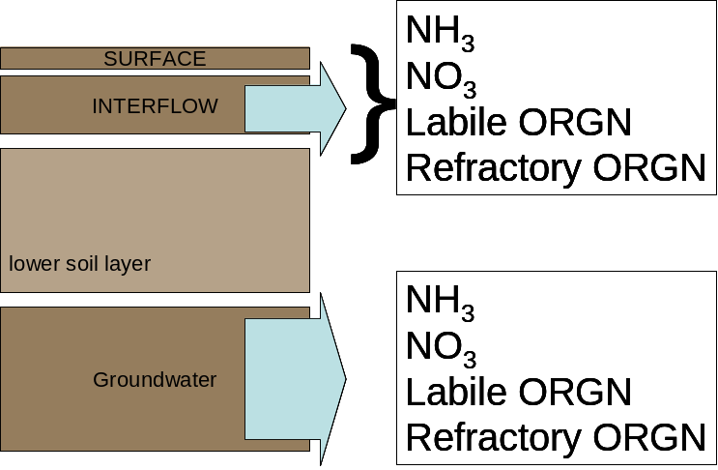

./BNO3_target.csv NO3 targets for groundwater layer
./BNH3_target.csv NH3 targets for groundwater layer
./BLON_target.csv Labile Organic targets for groundwater layer
./BRON_target.csv Refractory Organic targets for groundwater layer

./SNO3_target.csv NO3 targets for surface layer
./SNH3_target.csv NH3 targets for surface layer
./SLON_target.csv Labile Organic targets for surface layer
./SRON_target.csv Refractory Organic targets for surface layer

./BPO4_target.csv PO4 targets for groundwater layer
./SPO4_target.csv PO4 targets for surface layer

Besides the calibration targets, the TN and TP uptake targets also need to be specified. These two files: TN_uptake.csv, TP_uptake.csv, contain averaged observed uptake from ag censes years, and should come from Scenario Builder or outside calculation. The files are stored in the same places as the calibration targets.

3. Definition of target scenario, calibration constitutes, and limits of parameters
The target scenario, constituents with targets to be calibrated and limits of parameter are specified in data files for nitrogen and phosphorus:

For Nitrogen: ./config/control/calib/NITR/parameterscenario/nitr_names.dat
For Phosphorus: ./config/control/calib/PHOS/parameterscenario/phos_names.dat

- Review calibration results
The calibration results are summarized PLTGEN results, and are stored in.
. /output/pltgen/summary/Landscenario/

For each land use, as the calibration process repeats 10 times, each PLTGEN file will have 10 old files differentiated by version numbers. The files without version numbers are the newest ones and should be used to compare with targets.

The PLTGEN files are different constituents simulated for different soil layers in HSPF.
Here is what these constituents represent:
BNH4 ground water solution ammonia
SNH3 surface solution ammonia
DNH3 adsorbed ammonium
INH3 interflow solution ammonia

BNO3 groundwater nitrate
SNO3 surface nitrate
INO3 interflow nitrate

BLON groundwater labile organic
SLON surface labile organic N
DLON adsorbed labile organic N
ILON interflow labile organic N

BRON groundwater refractory organic
SRON surface refractory organic N
DRON adsorbed refractory organic N
IRON interflow refractory organic N

BPO4 groundwater phosphate
SPO4 surface phosphate
DPO4 adsorbed phosphate
IPO4 interflow phosphate

The generated PLTGEN files are not exactly corresponding to calibration targets. To compare with targets, this is how you do the trick:
1). Compare simulated groundwater results directly to target files for groundwater layer. In another word, no change for ‘B’ files.

2) Add simulated D, I and S results together to compare with surface targets. For example, you should compare (SLON +DLON+ILON) to SLON targets. There are no codes available to do this addition, I did manually in the past as there are not too much work.

- Compare/Present calibration results
A folder was created to store the comparison results. The folder is usually something like this: ./output/pltgen/summary/Land_Calib_results

Within this folder, a file for each land use can be found. Here is how each file is set up:
- The sheet All_BS contains the targets and simulated results for groundwater layer, each of nitrogen species each land segment.
- The sheet All_SU contains the targets and simulated results for surface layer, for each nitrogen species each land segment.
- The sheet PO4 contains the targets and simulated results for phosphorus species each land segment.
- TN sheet is summary of All_BS and All_SU, so will be automatically updated.
- Uptake_TN/Uptake_TP contain the simulated and target uptakes.
To get the simulated uptake, you will need to go to: run/useful/php/
For TN, run: get_uptake_nitr.sh 65 1 landuse landscenario landseg (‘all’ for all) annual_output_file summary_output_ file

For TP, run: get_uptake_phos.sh 65 1 landuse landscenario landseg (‘all’ for all) annual_output_file summary_output_ file

The summary_output_file is what you should get the simulated uptake results.

If you are going to use the results files as is, you will need to update both TARGETS and SIMULATED results for each land use, if both of them are changed. Normally, you only need to update simulated results because targets don’t change often.

